Name ______________________________ Homework March 20-24
Put your initials by each night that your child practiced the following:
____Monday ____Tuesday ____Thursday
*Nightly Homework*
1. Read the Start Right Reader page.
2. Count numbers 1-100.
3. Practice assigned Sight Word list in red reading folder.

Monday: Write the correct initial digraph for each word.
ch or sh

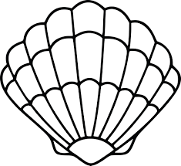 _______ 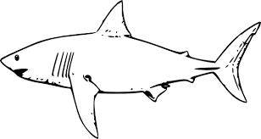 _______

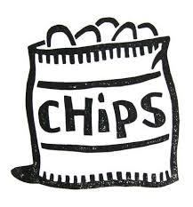 ______ 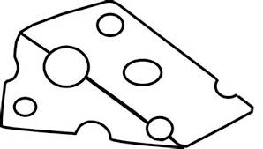 ______

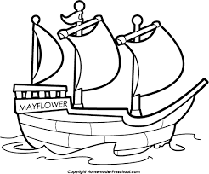 ______ 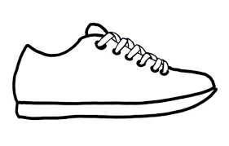 ______

Blend the phonemes together and draw a picture of the word.
/sh/ | /i/ | /p/
/ch/ | /i/ | /n/
Tuesday- Practice writing each spelling word three times.

chip chop fish wish
____ ____ ____ ____
____ ____ ____ ____
____ ____ ____ ____
chat ran she
____ ____ ____ ____
____ ____ ____ ____
____ ____ ____ ____

Thursday-Color the flower. Write three sentences to tell about your flower.

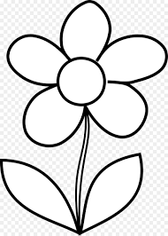

_________________________________________________

Start Right Reader Week of March 22-26
Directions: Let your child read this to you.

Words to Know
let were what

Chicks
Chip! Chip! Chip! Chip! What was in the shells? Chicks! Chicks were in the shells! Chicks snack on bugs. Quick, chicks! Peck at the bugs. Peck! Peck! Peck! Chicks have a mom. Mom is a red hen. Red hen clucks at her chicks. Cluck! Cluck! Chicks run from pests. So, red hen flaps in the dust to get rid of pests. Red hen will let chicks tuck in her chest. Snug chicks will nap well.

Comprehension Questions: (Parents, ask your child the questions about the story.)
What sound comes from the eggs? What are in the shells?
What do chicks snack on? How does red hen get rid of pests?
What do snug chicks do? Why do the ducks quack and flop?

Blend and Read: Read these words. Find these words in the story.
chicks chips
chest shell
get will her

Initial each night.
Mon. | Tues. | Thurs.

